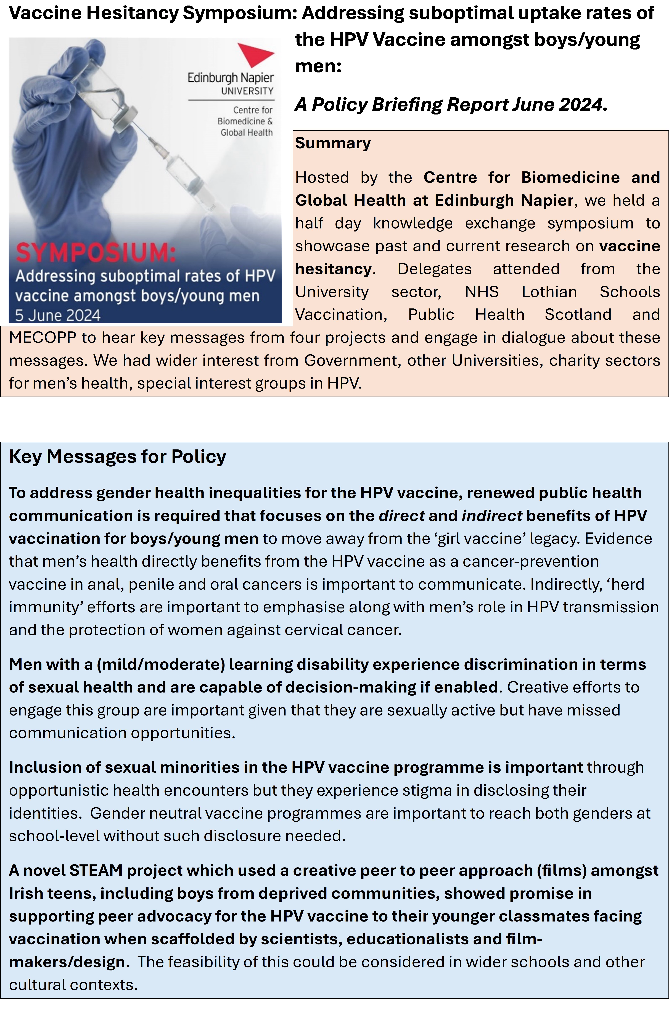
CIRE Recent work /Case Study Vaccine Hesitancy/Uptake Work

Chapter contribution (accepted/ forthcoming)

For Community Health Psychology: An Introductory Approach to Critical Public Health: (Accepted) Gray Brunton, C, Carnegie, E., Pow, J. & Todorova, I. Case Studies researching Human Papillomavirus (HPV) Vaccination and Reaching Hard-to-Reach Communities.

Recent Research Articles

Gray Brunton, C., Pow, J., Carnegie, E., Petrova, D., Garcia Retamero, R., Whittaker, A., & Todorova, I. (2025). Commentary and methodological insights: Reaching girls/women, boys/men and vulnerable groups to maximise uptake for the Human papillomavirus vaccine. Human Vaccines & Immunotherapeutics, 21(1). https://doi.org/10.1080/21645515.2025.2478705

Gray Brunton, C., Carnegie, E., Pow, J. et al. Young Men’s Communication Needs for the Human Papillomavirus (HPV) Vaccine: A Cross-Cultural, Qualitative Analysis in Scotland, Spain, and the USA. Int.J. Behav. Med. (2025). https://doi.org/10.1007/s12529-025-10387-6

Pow, J., Clarke, L., McHale, S., & Gray-Brunton, C. (2025). A systematic review and thematic synthesis exploring how gay, bisexual and other men who have sex with men (GBMSM) experience HPV and HPV vaccination. Human Vaccines & Immunotherapeutics, 21(1). https://doi.org/10.1080/21645515.2025.2490440

Carnegie, E., Gray-Brunton, C., Kennedy, C., Pow, J., Willis, D., & Whittaker, A. (2025). Young men with intellectual disabilities’ perceptions of HPV and HPV vaccine: A qualitative study on how to communicate HPV vaccine information. Human Vaccines & Immunotherapeutics, 21(1). https://doi.org/10.1080/21645515.2025.2491857

McInally, W., & Gray-Brunton, C. (2021). Research made simple: using multiperspective interpretative phenomenological analysis to explore healthcare phenomena. Evidence-Based Nursing, 71-73. https://ebn.bmj.com/content/ebnurs/24/3/71.full.pdf

Gray Brunton, C., Todorova, I., Petrova, D., Carnegie, E., & Whittaker, A., (2018). Using foucauldian discourse analysis to analyze young women’s constructions of the human papillomavirus vaccine. In Sage Research Methods Cases Part 2. SAGE Publications, Ltd., https://doi.org/10.4135/9781526440235

Carnegie, E., Whittaker, A., Gray Brunton, C., Hogg, R., Kennedy, C., Hilton, S., Harding, S., Pollock, K. G., & Pow, J. (2017). Development of a cross-cultural HPV community engagement model within Scotland. Health Education Journal, 76(4), 398-410. https://doi.org/10.1177/0017896916685592

You Tube Invited speakers:

How GBMSM experience HPV and HPV vaccination: A systematic review and thematic synthesis. 16 September 2025, Available on You Tube https://www.youtube.com/watch?v=md1JSrl06cc
- We were invited to by the Global Actions on Men’s Health and NOMAN to contribute to their Webinar on Men, Cancer and HPV: HPV prevention for gay, bisexual and men, including trans men, who have sex with men on a PhD study we have supervised.

Vaccine hesitancy amongst health and social care professionals, 2023. Interview by Dr Martin Lipscomb for Nursing Conversations, University of Worcester. Available on You Tube https://www.youtube.com/watch?v=d2IO76CeImw
From a Royal Society of Edinburgh Study that focused on health and social care professionals and COVID-19 vaccine hesitancy.

A Policy Briefing document:

Gray Brunton, C., Carnegie, E., Pow, J., Clarke, L., Malone, E., & Firth, R. Addressing suboptimal uptake rates of the HPV vaccine amongst boys/young men: A Policy briefing Report June 2024. Held at Edinburgh Napier University with academia, NHS and third sector partners:
- Addressing suboptimal uptake rates of the HPV vaccine amongst boys/young men: A Policy briefing Report June 2024

